Q1.] Write a Python Program to remove elements from set using remove() , discard() and pop().

Answer :

i). remove() method in a set removes an element from set . If the element is present in the set it will would be removed but the element doesn’t exist then it raises a key error .

ii).discard() method in a set removes an element from set like remove() method , although if element is not present in the set it does not raises any key error .

iii).pop()method in a set removes an arbitrary element from set as a set is unordered . So any random element will be discarded from set .

**PROGRAM:-**

lim = int(input("Enter the limit of sets: "))

countries = set()

print("Enter the elements of Set")

for i in range(lim):

ele = input()

countries.add(ele)

print("The set is:", countries)

foundele = input("Enter the element to get eliminated from sets: ")

if foundele in countries:

countries.discard(foundele)

print("The removed element using .discard() method is:", foundele)

try:

countries.remove(foundele)

print("The removed element using .remove() method is:", foundele)

except KeyError:

print("Element not found after using .discard() method.")

else:

print("Element not found in the set.")

if countries:

removed_element = countries.pop()

print("The removed element using .pop() method is:", removed_element)

else:

print("Set is empty after removing elements.")

**OUTPUT:-**

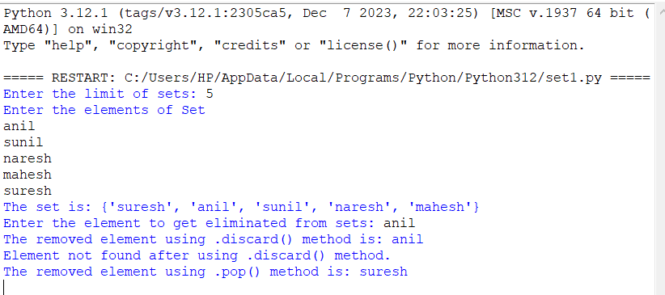

Q2.] Write a program to return a new set of identical items from two sets.

Answer :

i).**PROGRAM:-**

lim1 = int(input("Enter the limit of the set 1 : "))

lim2 = int(input("Enter the limit of the set 2"))

set1 = set()

set2 = set()

print("Enter the elements of set 1 : ")

for i in range(0,lim1):

ele1 = input()

set1.add(ele1)

print("Enter the elements of set 2 : ")

for j in range(0,lim2):

ele2 = input()

set2.add(ele2)

print("The set 1 is : " , set1)

print("The set 2 is : " , set2)

print("The identical elements from both sets are " , set1 & set2)

**OUTPUT:-**

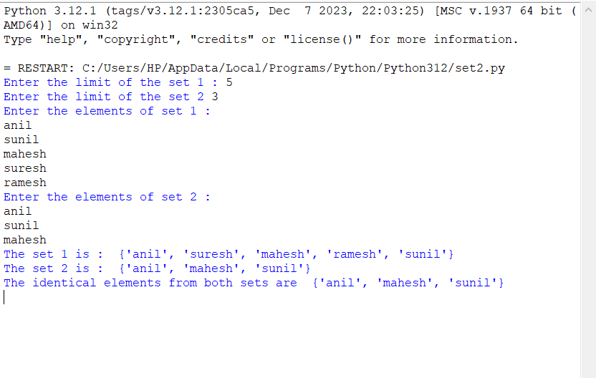

Q3.] Write a program to perform set operations :- Union , Intersection , difference and symmetric difference .

Answer :

i).**PROGRAM:-**

lim1 = int(input("Enter the limit of set 1 : "))

lim2 = int(input("Enter the limit of set 2 : "))

lim3 = int(input("Enter the limit of set 3 : "))

set1 = set()

set2 = set()

set3 = set()

print("Enter the elements of set 1 : ")

for i in range(0,lim1):

ele1 = input()

set1.add(ele1)

print("Enter the elements of set 2 : ")

for j in range(0,lim2):

ele2 = input()

set2.add(ele2)

print("Enter the elements of set 3 : ")

for k in range(0,lim3):

ele3 = input()

set3.add(ele3)

print("The set 1 is : " , set1)

print("The set 2 is : " , set2)

print("The set 3 is : " , set3)

print("The union of 3 sets are : " , set1 | set2 | set3)

print("The intersection of three sets are ", set1 & set2 & set3 )

print("The difference of 3 sets from set1 is " ,set1 - set2 - set3 )

print("The difference of 3 sets from set2 is " ,set2 - set1 - set3 )

print("The difference of 3 sets from set3 is " ,set3 - set2 - set1 )

print("The symmetric difference of 3 sets is : " , set1 ^ set2 ^ set3)

ii).**OUTPUT:-**

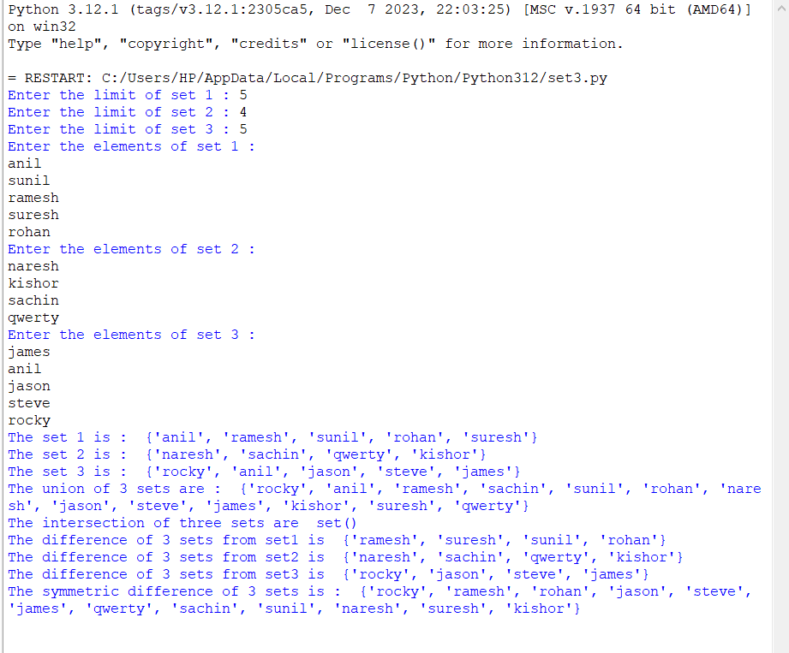

Q4.] Write a Python program to check if a set is a subset of another set .

Answer :

i).**PROGRAM:-**

lim_set = int(input("Enter the limit of set : "))

lim_subset = int(input("Enter the limit of subset : "))

sets= set()

subsets = set()

print("Enter the elements of set : ")

for i in range(0,lim_set):

ele_set = input()

sets.add(ele_set)

print("Enter the elements of subset : ")

for j in range(0,lim_subset):

ele_subset = input()

subsets.add(ele_subset)

print("The set is : " , sets)

print("The subset is " , subsets)

print("IF the entered subset is truely an subset of given set then it will return true else false ")

print(subsets.issubset(sets))

ii).**OUTPUT:-**

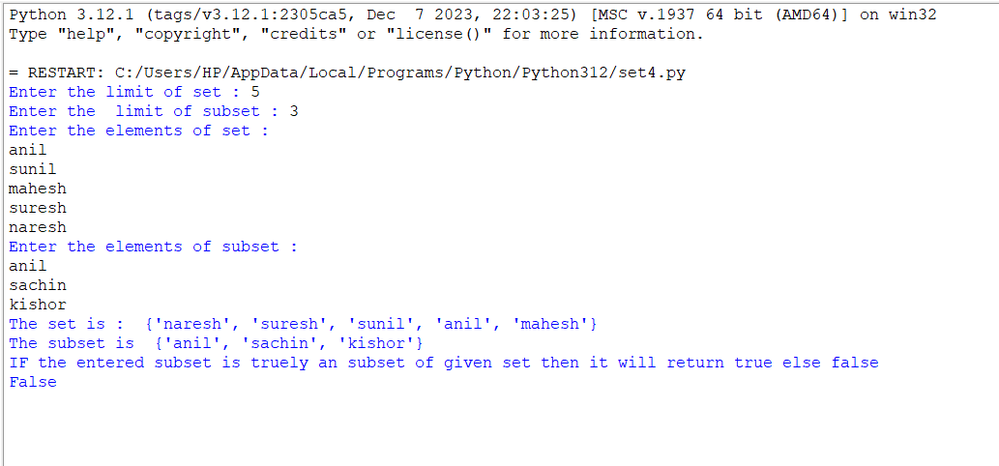

Q5.] Write a python program to make use of frozensets().

Answer :

i).**PROGRAM:-**

lim = int(input("Enter the limit of set: "))

sets = set()

print("Enter the elements of set:")

for i in range(0, lim):

ele = input()

sets.add(ele)

print("The set before using frozenset():", sets)

frozen_set = frozenset(sets)

print("Enter an element to be added in set:")

ele = input()

try:

frozen_set.add(ele)

print("The set after using frozenset() is:", frozen_set)

except AttributeError:

print("Cannot add elements to a frozenset.")

ii).**OUTPUT:-**

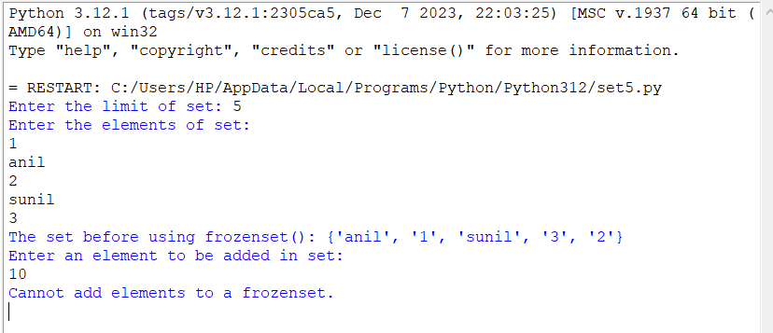

Q6.] Write a Python program to find and maximum and minimum element from a set .

Answer :

i).**PROGRAM:-**

lim = int(input("Enter the limit of the set :"))

sets = set()

print("Enter the elements of set : ")

for i in range(0,lim):

ele = int(input())

sets.add(ele)

print("The set is " , sets)

print("The maximum valued element in set is : " , max(sets))

print("The minimum valued element in set is : " , min(sets))

ii).**OUTPUT:-**

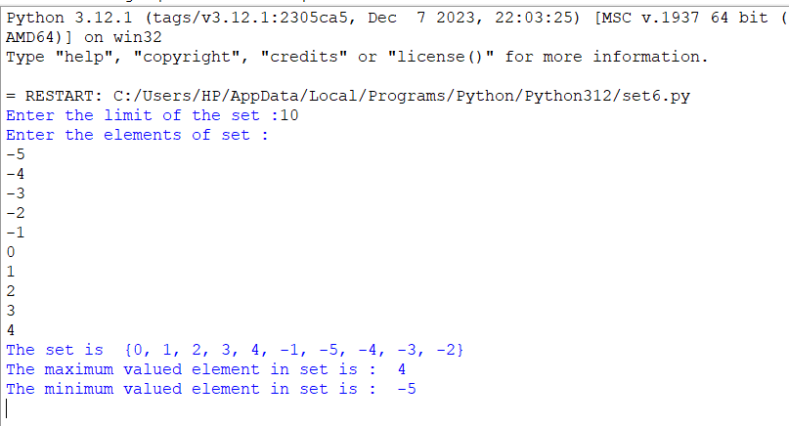

Q7.] Write a Python Program to find the index of an item of a tuple

Answer :

i**).PROGRAM:-**

lim = int(input("Enter the limit of tuple : "))

tuple1 = ()

print("Enter the elements of tuple")

for i in range(0,lim):

ele = input()

tuple1 = tuple1 + (ele,)

print("The tuple is : " , tuple1)

found_index = input("Enter the element whose is to be found : ")

for i in range(0,lim):

if tuple1[i] == found_index :

print("The element is found at " , i ,"value")

break

elif (i==lim-1 and tuple1[i] != found_index):

print("The element is not found in tuple ")

**OUTPUT:-**

